[cover sheet]

3

ASSIGNMENT 3

**CYCLOMATIC COMPLEXITY, PHASE 2**

CSE 6329 -- SOFTWARE MEASUREMENT AND QUALITY ENGINEERING

Professor Dennis J. Frailey

**Fall, 2019**

|  |  |
| --- | --- |
| NAME | STUDENT ID NUMBER |
| **Balaji Gurumoorthy** | **1001680348** |
| **Goutami Padmanabhan** | **1001669338** |

|  |  |
| --- | --- |
| **Name of Program Evaluated** | **Discussion of Any Errors Found and How to Correct Them** |
| Orange 6.c | Got the below warning while compiling the code in c compiler,  main.c:67:12: warning: implicit declaration of function ‘sqrt’ [-Wimplicit-function-declaration]  main.c:67:12: warning: incompatible implicit declaration of built-in function ‘sqrt’  main.c:67:12: note: include ‘<math.h>’ or provide a declaration of ‘sqrt’  Solution: To rectify above warning, include the below line before the main function  #include<math.h> |

|  |  |  |  |  |
| --- | --- | --- | --- | --- |
| **Cyclomatic Complexity Calculation** | | | | |
| **Arcs** | **Nodes** | **C (Number of Separate Flowgraphs)** | **Arcs - Nodes** | **Arcs – Nodes + 2C**  **(Cyclomatic Complexity)** |
| 35 | 25 | 1 | 10 | 12 |

**Place flowgraph on next page.**

**Flow Graph:**

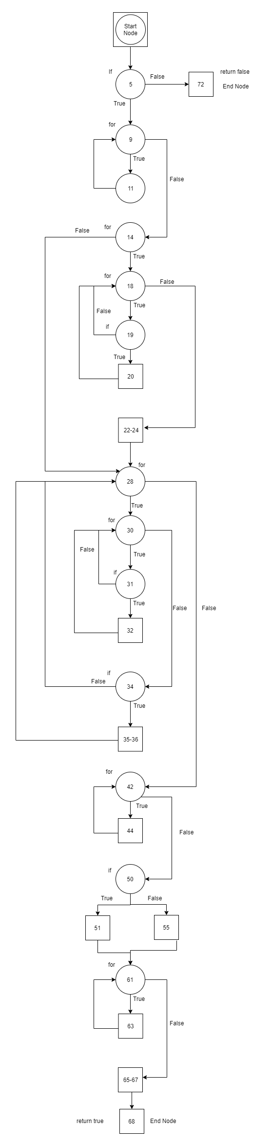

**Cyclomatic Complexity:**

**Number of Edges (e): 35**

**Number of Node (n): 25**

**Number of Separate Flow Graphs (C): 1**

Cyclomatic Complexity of Main Function = e-n+2C

= 35-25+2*1

= 10+2

= **12**